What if…
Reasoning about the book, before touching it
A new capability across three surfaces · 268 tests pass

Treasurers spend a lot of the day answering questions of the form “what would happen if…”. What if this counterparty is downgraded? What if we do not roll this at maturity? What if the concentration cap tightens? Until now those questions were answered on paper or in a spreadsheet, away from the book, with figures a person had to look up and combine by hand.
This is now a first-class capability of the register. Three scenarios are shipped, each one alongside the thing the reader would ask about. Every figure in every answer is computed by the same code that computes today’s figures; the AI writes the paragraph that reads them.

The rule that makes it safe to ship
The AI does not decide any number. Rating changes are applied inside a database savepoint that is rolled back at the end of the call, so the book is not touched. The other two scenarios are computed in memory. The paragraph the model writes is constrained to quote figures from the deterministic change list beside it — nothing invented, no hallucinated rates or amounts. Every screen shows both, side by side.

1. What if this rating changes?
Lives in the Ratings & Policy panel, beside the existing Apply, and re-test the book action. A new What would this do? button opens a preview: the paragraph and the list of what would move. Preview first, then act.
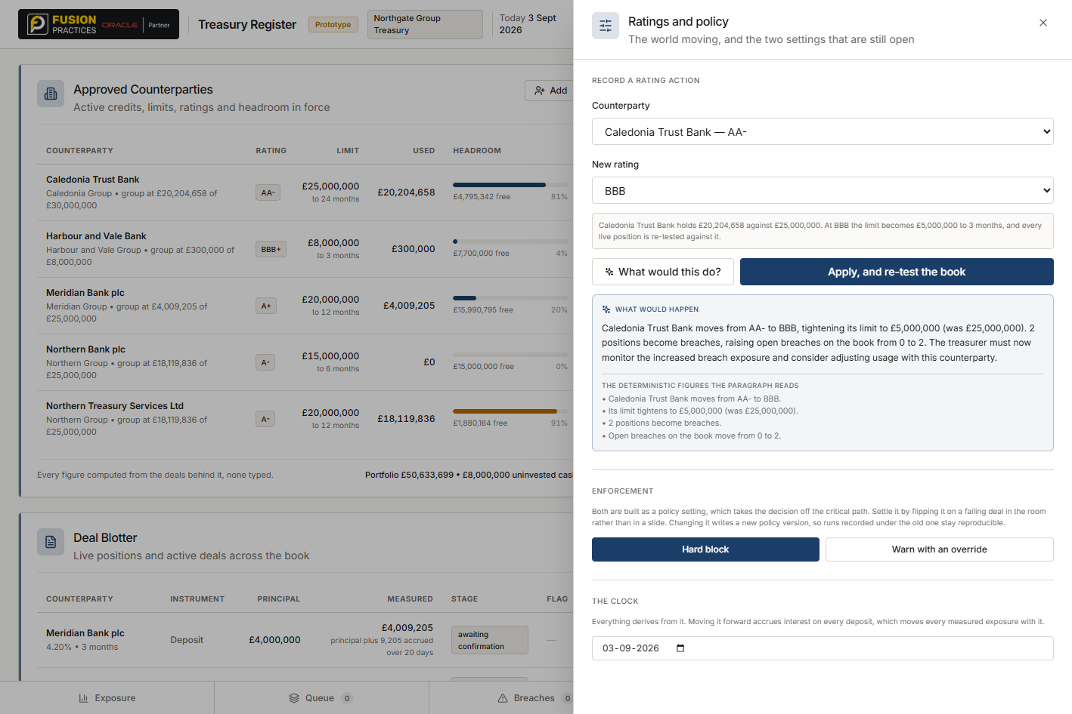
Figure 1. A downgrade previewed. AI paragraph on top, deterministic list below.

2. What if the concentration cap moved?
Lives at the bottom of the Counterparty exposure tab. Enter a new cap percentage; the concentration check runs against it and every group that would cross the line is named. Useful when a policy revision is on the table and the treasurer needs to see the cost.
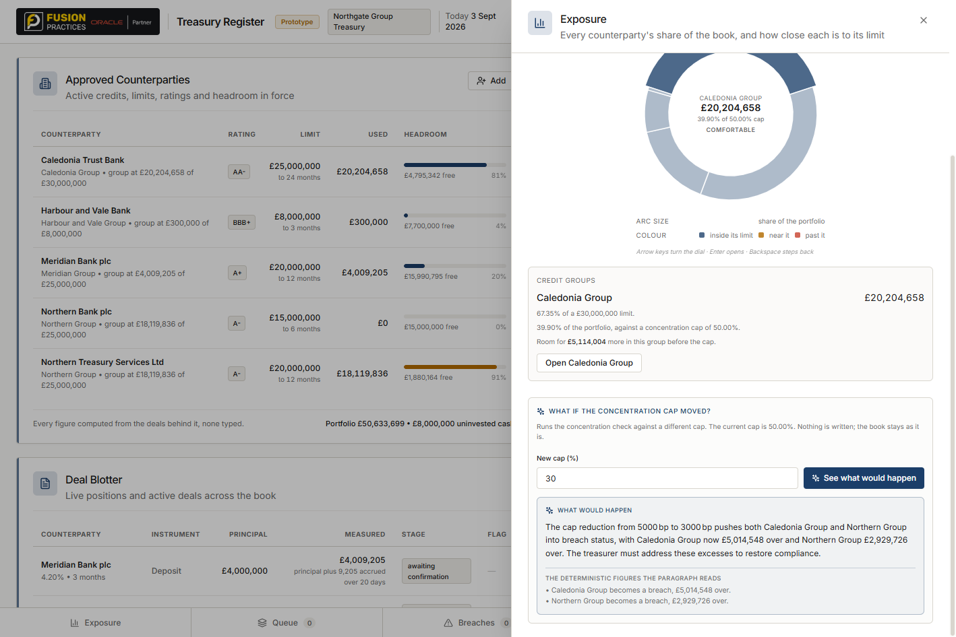
Figure 2. Modelling a tighter cap. Two groups become breaches, quantified.

3. What if this deal is not rolled at maturity?
Lives inside the deal panel, between the settlement section and the accruals. Answers what the cash lands as, which counterparty releases how much headroom, and how much daily interest stops. A recurring question at the point on the screen where the deal itself sits.
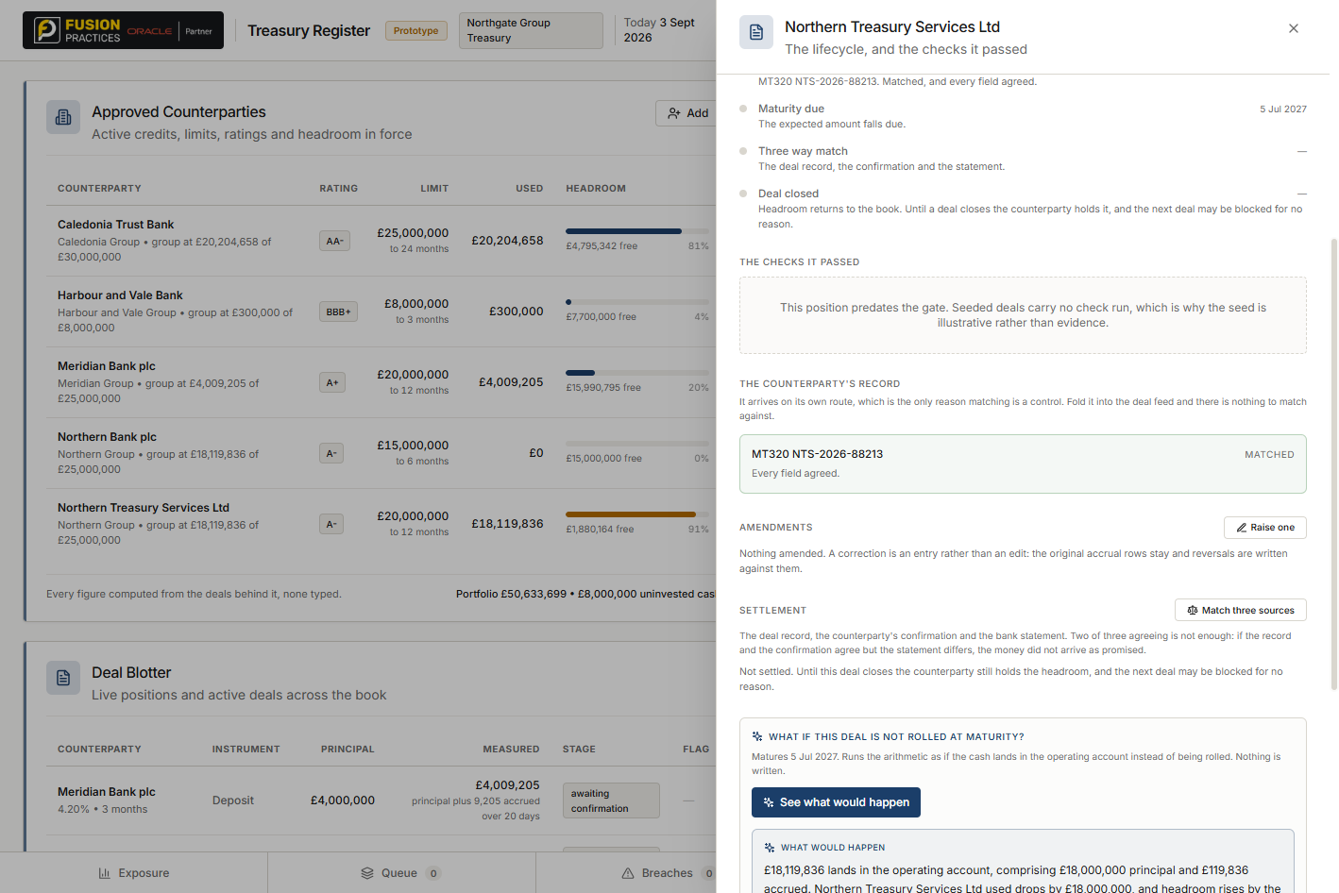
Figure 3. Modelling a non-roll. Cash, headroom, and lost income laid out.

Why every scenario has the same shape
The card carries two things: the model’s paragraph, and the deterministic figures that paragraph reads. A treasurer who wants the summary reads the paragraph. One who wants to check the model’s work reads the list. Both on the same card, because both are the same answer.
The buttons live beside the thing the scenario is about — rating change beside the rating action, cap change under the concentration picture, not-rolled beside the deal. Nothing here is a new panel; the strip stays at five items. The AI is added where the question would naturally be asked, not off to one side.

The engineering shape
The whole capability is three service methods, one router, one narrator and one shared frontend card. The service methods run the same code that the live checks run, so the day the CheckEngine changes shape, the scenarios follow it without a code change. Fallback is automatic: if the model is unavailable, the paragraph is the concatenated change list, which is still a correct answer.

Treasury Register · What-if capability · three scenarios · book dated 3 September 2026

